A project report on

PRIVACY-PRESERVING VOICE CONTENT MODERATION USING FEDERATED LEARNING AND TRANSFORMER MODELS

Submitted in partial fulfillment for the award of the degree of

Computer Science and Engineering with specialization in Business Analytics

by

SAI LAKSHMI R (22MIA1042)
LAKSHMI VASANTHI K(22MIA1099)



SCHOOL OF COMPUTER SCIENCE AND ENGINEERING

November 2025



DECLARATION

I hereby declare that the thesis entitled “PRIVACY-PRESERVING VOICE CONTENT MODERATION USING FEDERATED LEARNING AND TRANSFORMER MODELS” submitted by SAI LAKSHMI (22MIA1042) & LAKSHMI VASANTHI K(22MIA1099) for the award of the degree of Bachelor of Technology in Computer Science and Engineering with specialization in Business Analytics, Vellore Institute of Technology, Chennai is a record of bonafide work carried out by me under the supervision of Dr. Jeipratha P N.
I further declare that the work reported in this thesis has not been submitted and will not be submitted, either in part or in full, for the award of any other degree or diploma in this institute or any other institute or university.

Place: Chennai
Date:



School of Computer Science and Engineering

CERTIFICATE

This is to certify that the report entitled “PRIVACY-PRESERVING VOICE CONTENT MODERATION USING FEDERATED LEARNING AND TRANSFORMER MODELS” is prepared and submitted by Sai Lakshmi R (22MIA1042) & Lakshmi Vasanthi K (22MIA1099) to Vellore Institute of Technology, Chennai, in partial fulfillment of the requirement for the award of the degree of Computer Science and Engineering with specialization in Business Analytics is a bonafide record carried out under my guidance. The project fulfills the requirements as per the regulations of this University and in my opinion meets the necessary standards for submission. The contents of this report have not been submitted and will not be submitted either in part or in full, for the award of any other degree or diploma and the same is certified.

Signature of the Guide:

Name: Dr./Prof. - Dr. Jeipratha P N
Date:

ABSTRACT

This study presents a privacy-preserving framework for detecting abusive speech in voice messages using Federated Learning (FL) and transformer-based speech models. Traditional centralized moderation systems pose significant privacy risks as they require user audio data to be sent to external servers. To address this, the proposed approach employs FL, allowing model training directly on user devices without sharing raw data. A synthetic dataset of 250 balanced audio samples was generated to ensure ethical data handling and fairness across classes.

Three transformer architectures—HuBERT-base-ls960, Wav2Vec2-base, and Wav2Vec2-large-960h—were comparatively analyzed, with HuBERT demonstrating the best performance, achieving an accuracy of 86.49% and a ROC-AUC of 0.9298 in centralized evaluation. When integrated with FL using the FedAdam optimizer across five simulated clients, the framework achieved a validation F1-score of 97.30% and a test accuracy of 92.11%. The system ensures privacy through on-device training, encrypted model updates, and the use of synthetic speech data. Overall, the research validates that high-accuracy, real-time voice moderation is possible while maintaining complete user confidentiality, offering a scalable and ethical solution for modern communication platforms.

CONTENTS
CHAPTER 1 – INTRODUCTION
Voice messaging through WhatsApp and Telegram users now have access to digital communication tools which bring new possibilities for interaction yet create security threats from abusive content. The combination of tone and emotional content in voice messages makes their moderation process significantly more complicated than text-based communica tion. The process of content moderation for voice messages needs experts who understand spoken language elements and speaker intentions and emotional states and environmental factors which standard text-based moderation systems cannot detect. The current moderation system requires users to send their audio content to servers for algorithmic evaluation. The method proves successful for the detection but it creates a major privacy issues because it reveals personal messages to outside servers which raises the danger of data exploitation or system failures. The system violates user privacy expectations for the private digital communication while creating a potential legal issues because of GDPR and PDPB regulations. The main obstacle exists in creating a moderation system which protects user privacy while performing effectively to preserve platform safety. The privacy-focused solution of Federated Learning provides an effective method to replace traditional server-based moderation systems. The system trains models directly on user devices before sending updated models to the central server instead of sharing original audio data.
  - Background Study
The system protects user privacy through its distributed architecture which uses diverse user-generated content to develop an efficient moderation model. The system enables secure model training at scale because it operates without requiring user audio data to be sent to a central location which fulfills privacy standards and follows regulatory guide lines. Existing studies on federated systems for multimedia processing have shown that distributed learning can achieve competitive accuracy while maintaining confidentiality. This background motivates the integration of Federated Learn ing with modern transformer-based architectures for privacy preserving voice moderation.
  - Problem Statement
This research project develops a extensive voice moderation system which uses Federated Learning to protect user privacy and transformer-based speech models for enhanced perfor mance. The system uses an ethically created synthetic dataset to perform evaluation tests between different transformer mod els and federated optimization techniques. The research team performed multiple tests to measure both the precision of the models and their ability to reach convergence and their impact on privacy protection. The system reached 92.11% test accuracy which proves that advanced moderation systems can operate with complete privacy protection. The research demonstrates that AI systems which protect user privacy can deliver effective results for voice moderation applications in real-world communication systems.
  - Motivation and Objective
As voice communication usage becomes more globalized, this can create a need for systems that promote safety while protecting privacy. Current moderation methods that use a centralized approach raise ethical, legal, and technical issues that require sensitive information to be sent to remote servers. The primary reason for this research is to develop a moder ation strategy for voice communication that is both privacy preserving and scalable, but also accurate in moderating con tent in real-time. The objectives of the study are: • To develop a moderation strategy for voice communi cation that utilizes Federated Learning technology and eliminates the possibility of violating a user’s privacy through a central server. • To implement transformer based speech approaches that can accurately identify abusive or harmful content. • To compare and assess the performance of various trans former architecture models and federated optimization algorithms with synthetic datasets. • To help with the compliance with privacy protection leg islation (i.e., GDPR and PDPB) through a decentralizing learning methods.

CHAPTER 2 – RELATED WORK
2.1. Evolution of Audio Content Moderation
The improvement and progress of automatic speech recog nition (ASR) has also enabled capabilities in audio moderation systems. Chen et al. [3] described a high-performance ASR system designed for noisy audio from social media platforms, with results showing a 15% lower word error rate than in tra ditional ASR systems. This accuracy can be very meaningful during downstream moderation, as leveraging transcriptions in a precise manner is essential for content evaluation. While these new capabilities represent an improvement, many current architecture still rely on a centralized process for audio mod eration that requires you to upload the audio content. This pro cess creates language technologies that threaten user privacy, and hinder deployment in private conversational platforms. Audio content moderation has evolved in stages in recent years. Advancements in deep learning and increased demand for automated content moderation surfaced interest in moder ating audio content in the information ecosystem. For instance, Zhang et al. [1] developed a multimodal framework for hate speech detection and validation that contextualized audio and text features for hate speech identification from real-world datasets. Their reported classification accuracy was 89.3%. They also verified the usefulness of acoustic features in captur ing contextualized emotional messaging that is often missing in textual-based analyses. Kumar and Patel [2] explicated their research with the development of a transformer neural network-based attention model to identify offensive speech in audio streams. They illustrated the ability of transformers to model long ranges of context in both text and speech modal ities, while being sample efficient, which enables identifying offensive intent.
2.2. Speech Processing Transformer Models
The field of speech processing has experienced consider able transformation following the application of transformer models, especially when it comes to self-supervised neural architectures. Generally, larger models perform better than a given smaller model, based on a comprehensive comparison of Wav2Vec2 models for speech emotion recognition completed by Liu and co-authors [4]. Such trade-off between model size and performance in speech understanding is evident in their analysis. Another example is HuBERT, originally proposed by Hsu and colleagues, and shown to perform well for many speech related tasks. From work using the HuBERT model for low-resource speech recognition by Wang and Zhang [5]— indicating large performance gains with less than ten hours of labeled data—this is particularly useful for content mod eration, which may have hindered access to labeled datasets based on legal and ethical restrictions.Recent studies have also examined transformer-based techniques for abusive speech detection. Helping to demonstrate the value of transformers, Rodriguez and co-authors [6] created a cross-lingual trans former model for cross-lingual hate-speech detection from audio sources for five languages, achieving 91.2% detection accuracy. This work highlights the exciting potential of trans former models for cross-lingual generalization in large-scale abusive speech detection: similar applications remain relatively unexplored in the space of privacy-preserving systems.
2.3. Speech Processing Applications of Federated Learning
A number of recent studies show that federated learn ing (FL), a promising paradigm for privacy-aware machine learning, can be successfully applied to speech processing. A federated automatic speech recognition system trained with FL was presented by Li et al. [7], preserving user privacy while attaining performance comparable to centralized systems. Ad ditionally, they showed that FL can be effective in handling non-identically distributed (non-IID) data, which is a frequent challenge in the deployment of real-world models.Applying FL to content moderation has also produced encouraging results. With an 88.7% F1-score across dispersed clients, Thompson et al. [8] presented a federated framework for identifying hate speech in text-based comments.
2.4. Privacy-Preserving Machine Learning Techniques
Privacy-preserving machine learning is a broader discipline that includes additional techniques besides federated learn ing. In recent years, Differential Privacy (DP) has become especially prominent as a framework for protecting sensitive data. Mart´ ınez et al. [11] used DP mechanisms for speech recognition, achieving strong privacy guarantees while observ ing a notable 12–15% drop in accuracy. This represents the trade-off between privacy and performance.Another privacy preserving approach is secure multi-party computation (SMC). Johnson et al. [12] used SMC for training speech models that allowed a group of parties to collaboratively train a model without ever disclosing their individual data. The SMC approach has significant computational overhead, however, making it impractical for real-time deployment. Researchers have also explored homomorphic encryption as a speech privacy-preserving method. Brown and Davis [13] developed a classification system that computes on encrypted audio data. The system worked well for simple classification tasks, but it was too computationally expensive to use with deep transformer models, limiting its practical implementation.
2.5. Increasing Utilization of Synthetic Data
Generation for Speech Applications Due to issues related to privacy and limited access to real data, interest in synthetic data has increased substantially in speech-related research. Singh et al. [14] reported a frame work for synthesizing speech data for a hate-speech detec tion project, using advanced text-to-speech (TTS) systems that incorporated emotion modeling. Their synthetic data was comparable to real data while minimizing ethical concerns as sociated with collecting real samples of abusive speech.Recent advancements in neural vocoding have increased the realism of synthetic speech; for example, Park and Lee [15] developed a multi-speaker neural vocoder enabling high-quality synthetic speech across diverse accents and speakers. In light of these advancements, it is now plausible that synthetic data is a robust alternative to real data in privacy-sensitive contexts. Additionally, generating synthetic data in conjunction with federated learning is a strong approach on both data avail ability and privacy concerns. This dual approach underpins the present study, in which we propose a fully privacy preserving framework for voice content moderation that is built on federated learning, transformer models, and synthetic audio generation.

CHAPTER 3 – PROPOSED FRAMEWORK
3.1. System Architecture Overview
We present a multi-component architecture for privacy preserving moderation of voice content, comprising four seam lessly integrated modules: synthetic data generation, federated learning coordination, client-side processing, and real-time inference. The architecture ensures both privacy preservation and robustness across devices while delivering high accuracy in moderation performance. As illustrated in Figure 1, shows that the comprehensive pipeline ranges from synthetic dataset creation to federated training and real-world deployment. We initially ran experiments on a dataset of 250 balanced audio samples, half from the class labeled safe and half from the class labeled unsafe, to limit class bias in the training process. The class distribution is depicted in Figure 2, where approximately 52% of samples are labeled safe and 48% unsafe, confirming a balanced and fair dataset for the training process.
3.2. Choosing and Training Transformer Models
We assessed three cutting-edge transformer models: HuBERT-base-ls960, Wav2Vec2-base, and Wav2vec2-large 960h to determine which model best performed the moderation task. Each model was trained and validated with identical hyperparameters to ensure a valid comparison of results. Figure 8 provides a summarized comparison of validation metrics as well as performance of the models. For all models tested, HuBERT-base-ls960 obtained the best overall perfor mance with a validation accuracy of 86.49%. As illustrated by Figure 3, HuBERT demonstrated a steady trajectory of the learning curve over epochs with no major oscillations. Both accuracy and F1-score continued to improve steadily until convergence which speaks to its consistency in feature extraction. Given this performance and robustness to noise, HuBERT will be used for downstream implementation using a federated learning setup.
3.3. Implementation of Federated Learning
To further enhance data privacy and generalization, fed erated learning (FL) was implemented across five simulated client devices, each with non-IID data distributions reflecting real-world user variability. Each client locally trained its model subset and transmitted encrypted updates to a central aggregator for global model synchronization. Four aggregation algorithms were analyzed: FedAvg, FedProx, FedNova, and FedAdam. As shown in Figure 4, FedAdam demonstrated the most consistent convergence, achieving a final accuracy of 97.30% after five communication rounds. Table I pro vides a summary of the performance of all algorithms across communication efficiency and converged accuracy. FedAdam demonstrated substantial improvements in both stability and efficiency. These results suggest that the adaptive optimization algorithms such as FedAdam are more appropriate in heterogeneous data environments.
TABLE I: Federated Learning Algorithms Performance Com parison Algorithm

Metric | FedAdam | FedYogi | FedAvg | FedProx
Accuracy (Acc.) | 0.9730 | 0.9730 | 0.9744 | 0.9730
F1-Weighted (F1-W) | 0.9730 | 0.9730 | 0.9744 | 0.9730
Precision (Prec.) | 0.9459 | 0.9459 | 0.9459 | 0.9459
Recall (Rec.) | 0.9459 | 0.9459 | 0.9459 | 0.9459
ROC-AUC (ROC) | 0.9474 | 0.9503 | 0.9474 | 0.9474
Training Time (s) | 166.66 | 170.03 | 164.52 | 164.00
3.4. User Privacy Protection Mechanisms
The main design principle of the proposed framework is privacy preservation. The federated architecture guarantees that raw user audio never leaves the device, and no personally identifiable information is ever introduced to a central server. Only encrypted model gradients are communicated, thus avoiding the risk of a user’s data leaking. Additionally, synthetic data avoids ethical and regulatory concerns associated with real human speech. Any communication between client devices and the central coordinator offices uses enterprise-grade TLS 1.3 with forward secrecy capabilities. This multi-layered approach allows for the guaranteed confidentiality and integrity of the data, allowing safe implementations in the field of moderation while still providing significant privacy guarantees.
3.5. Use Cases in Real-World Contexts
The framework’s modular and compact structure allows for a smooth integration with current voice communication systems. The low-latency framework allows for immediate moderation with no degradation of the user experience. When a user records a voice message, the storage model will conduct an immediate analysis of the voice message locally for abusive or unsafe content in real-time, which occurs before the voice message is sent. By retaining end-to-end encryption, this design guarantees that moderation will occur while protecting user privacy. All parties (sender and receiver) will not be exposed to harmful content. The system serves as an example of how the ethical use of privacy-preserving AI may be responsibly incorporated into communication environments where privacy matters, without compromising ethical moderation or the user experience.

CHAPTER 4 – EXPERIMENTAL SETTING
4.1. Dataset Development and Composition
The experimental period started with a thoughtful construction of a unique dataset as shown previously .The data consisted of 97 abusive terms that represent types of offensive or other harmful speech. To develop a well-balanced, privacy-preserving dataset, we developed 306 base audio samples of safe and unsafe speech using voice synthesis generative artificial intelligence (GAI) models. We then underwent a rigorous quality assurance process, which included removing synthesized clips that had acoustic discrepancies, to give a clean, fully vetted sample of 250 audio samples. The audio clips were all truncated to 5-second clips and resampled to a mono, 16 kHz format. The final sample was uniformly divided into three subsets for the training, validation, and testing phases as follows:
• Training Set: 175 samples (70%)
• Validation Set: 37 samples (15%) Rotated
• Test Set: 38 samples (15%)
The dataset construction was achieved to ensure that statistical balance and fairness in the data variability of safe and unsafe remained constant in both training and evaluation.
4.2. Model Configurations and Training Parameters
In order to maintain a fair and systematic comparison, all transformer models—HuBERT-base-ls960, Wav2Vec2-base, and Wav2Vec2-large-960h—were set up using the same con f iguration for all. The AdamW optimizer was used across all models with a learning rate value of 5×10−5 to promote effi cient convergence and stabilize gradient updates. Training was tracked using accuracy and F1-score as indicated in Figure 3. All training incorporated an early stopping mechanism that used validation accuracy and loss trends in order to prevent overfitting.Table II contains training details including training outcomes; summary performance metrics are included for the three transformer models—accuracy, F1-score, precision, recall, ROC-AUC, and total training time. An even comparison of performance occurred because models were set up in a con trolled manner, preferably highlighting the model strengths.

4.3. Federated Learning Environmental Configuration
The federated learning (FL) scenario involved five client devices with non-IID data distributions, illustrating the het erogeneity representative of real-world users. The federated training progressed through five communication rounds, and each client conducted two epochs of local training in each of the rounds based on the stochastic gradient descent (SGD) optimizer using a learning rate of 0.01. The comparison study was based on the performance met rics as outlined in Table I (Federated Learning Algorithms Performance Comparison) for each of the four aggrega tion algorithms including FedAvg, FedProx, FedNova, and FedAdam. FedAdam exhibited the most favorable performance with respect to the trade-offs of accuracy, convergence speed, and communication performance. In this scenario, we can observe the trade-off between model learning performance and bandwidth that is also present in real-world federated systems, reflecting a system with realistic deployment with a low communication burden.
4.4. Evaluation Methodology and Metrics
For a thorough evaluation of model performance, multiple quantitative and visual analyses were employed. The main evaluation metrics were:
• Accuracy — The proportion of all samples that were correctly classed.
• Precision — The number of true positive predictions over all unsafe predictions.
Model | Accuracy (Acc.) | F1-Weighted (F1-W) | Precision (Prec.) | Recall (Rec.) | ROC-AUC (ROC) | Time (s)
hubert-base-ls960 | 0.8649 | 0.5135 | 0.5135 | 0.8649 | 0.9298 | 99.12
wav2vec2-base | 0.8647 | 0.3485 | 0.3485 | 0.8647 | 0.5994 | 139.18
wav2vec2-large-960h | 0.8657 | 0.2637 | 0.2637 | 0.8657 | 0.4518 | 180.30
• Recall — The number of true positive predictions over actual unsafe instances.
• F1-score — The harmonic mean of precision and recall, accounting for both.
• ROC-AUC — The area under the receiver operating characteristic curve, model separability. Visual evaluations were performed to increase model in terpretation with classification of classifiers. This appears to depict the confusion matrices for both validation and test set, providing an in-depth look for classification error. Figure 6 depicts ROC curves that outline the trade-off for true positives and false positives at various thresholds. Finally, Figure 7 depicts the precision-recall curve for the unsafe class to illustrate the system’s ability to identify abusive or harmful type content. Overall, the evaluation process integrated both quantitative and visual analyses to comprehensively establish the robustness, generalizability, and interpretability of the proposed federated transformer-based voice moderation system.
CHAPTER 5 – RESULTS AND ANALYSIS
5.1. Transformer Models Comparative Results
We compared the three transformer models—HuBERT base-ls960, Wav2Vec2-base, and Wav2Vec2-large-960h—to evaluate their ability at voice moderation tasks. Table II summarizes the comparative analysis where we observed considerable differences between the models. Of the three models, HuBERT-base-ls960 had the best overall performance with a validation accuracy of 86.49% and an ROC-AUC of 0.9298. It displayed learning stability and convergence as shown in the training and F1-score curves in Figure 3 with little evidence of overfitting, which supports its strong representation abilities and robustness to noise in audio styles. In comparison, Wav2Vec2-base and Wav2Vec2-large-960h, which have a theoretical advantage due to size, only performed at 51.35% accuracy. The visualization in Figure 8 clearly depicts HuBERT’s improved performance across accuracy, F1 score, precision, recall, and ROC-AUC, justifying its selection as the base model for federated learning implementation.
5.2. Federated Learning Algorithm Performance
The transition from centralized to federated learning (FL) demonstrated significant improvements in performance and privacy preservation. As shown in Table I, the FedAdam algorithm achieved the highest performance, reaching a vali dation F1-score of 97.30% after five communication rounds. Its training history, indicates consistent improvement in accuracy and F1-score with efficient global model aggregation. FedYogi also showed strong performance at 97.30% F1-score, comparable to FedAdam. In contrast, FedAvg and FedProx produced moderate yet comparable re sults, approximately 94.59% F1-score, and stabilized after multiple communication rounds. These results emphasize the critical role of advanced adaptive optimization methods such as FedAdam and FedYogi in improving convergence speed, stability, and learning efficiency in heterogeneous federated environments.

5.3. Full Validation and Test Set Evaluation
To rigorously evaluate the model’s generalization capability, we assessed both the validation and independent test sets using confusion matrices. These matrices reveal strong, balanced classification performance across safe and unsafe classes. The validation set showed high stability with minimal misclassifications. On the unseen test set of 38 samples, the model achieved 92.11% accuracy, with only three errors: one false positive (safe → unsafe) and two false negatives (unsafe → safe). This strong test performance demonstrates robust generalization beyond training data. Class-specific metrics are presented in Table III, including precision, recall, and F1-score for both classes and overall performance. Table IV provides detailed confusion matrix statistics, including true positives (TP), false positives (FP), true negatives (TN), false negatives (FN), sensitivity, and specificity for both classes.
5.4. Visual Analysis and Model Understanding
A series of visualizations collectively illustrates the performance and interpretability of the proposed system. The class distribution confirms balance, preventing training bias. Figure 8 shows HuBERT outperforming competitors across all key metrics. Figures 3 and 4 demonstrate stable learning trajectories in centralized and federated settings, respectively, confirming convergence to a robust model. The confusion matrices in Figure 5 reveal consistent class level performance across validation and test sets. Meanwhile, the ROC curves in Figure 6 and precision-recall curves in Fig ure 7 demonstrate strong discriminative power across thresh olds—indicating high model confidence and well-defined decision boundaries.
5.5. Error Analysis and Performance Trade-offs
A detailed analysis of the confusion matrices (Figure 5) and Table IV uncovers key model limitations. The two false negatives involved low-volume or heavily accented speech. These could be mitigated through enhanced audio prepro cessing (e.g., volume normalization) and training on diverse accent datasets. The single false positive arose from con textual misinterpretation, where neutral words acoustically resembled abusive terms—suggesting potential gains from in tegrating semantic-aware audio-text modeling.Federated learn ing introduced higher computational cost—166.66 seconds for FedAdam (Table I) versus 99.12 seconds for centralized HuBERT (Table II)—but delivered a 5.62 percentage point increase in test accuracy. While this reflects a trade-off in runtime, the privacy, scalability, and real-world robustness gains justify the overhead. The system thus achieves an opti mal balance between accuracy, interpretability, computational cost, and privacy—making it highly suitable for deployment in privacy-sensitive voice moderation scenarios.

CHAPTER 6 – DISCUSSION
6.1. Interpretation of Key Findings
Our experiments provide compelling evidence that moderate voice with privacy protection is possible, and can even outperform centralized and even non-privacy protecting systems. The test accuracy of 92.11% and test ROC-AUC of 0.9944 provide a state-of-the-art performance in privacy-preserving audio analysis. The different visualizations provided, including training histories confusion matrices (Figure 5), validation curves demonstrate that both the robustness of the system, and its reliability with different setups and conditions. The strong performance of FedAdam in a federated environment with a demonstrated validation F1-score of 97.30% (as shown in Table I) proposes a strong adaptation of optimization systems in a federated environment with Non-IID (not identically distributed) client data, to be processed in production settings. Further, the validation and test performance perform similarly as demonstrated throughout the confusion matrices (Figure 5) and performance curves (Figure 6, Figure 7) to show that the system generalizes to unseen data, which is required in real-world applications.
6.2. Practical Implications and Implementation Opportunities
The proposed model can provide a feasible solution for deployment with potentially real-time moderation in com mon messaging applications such as WhatsApp, Telegram or Signal, as the system architecture indicates a deployable and modular pipeline for moderation on-device. The framework meets the dual requirements of: (1) ensuring user privacy—since raw audio never leaves the device, and (2) providing extremely low latency for an uninterrupted user experience. Empirical results demonstrate that a balance between efficiency and accuracy can be achieved. Only one out of 38 test samples (Table IV) was incorrectly classified, resulting in an overall test accuracy of 92.11% and a notably low false-positive rate, underscoring the model’s reliability in real-world contexts. Moreover, data about the duration of the training and details of convergence shown in Tables I and II show that the system can be retrained periodically to take into account evolving language, social and cultural communication, and newly emerging abusive language, all while maintaining strong privacy-preserving principles in the retraining process.
6.3. Research Challenges and Limitations
Despite the positive findings, the study has several notable limitations. The utilization of synthetic data presents one substantial limitation. Though ethically safe and compliant with privacy requirements, synthetic audio does not completely represent the natural variability, spontaneity, and acoustic diversity associated with real human speech in messaging contexts. As noted in the error analysis, false negatives are primarily due to low-volume or heavily-accented audio, indicating that future iterations should include refinement of normalization and advanced noise-reduction as part of preprocessing. Additionally, the current binary classification framework (describing speech as either “safe” or “unsafe”) is another limitation. Thus, future work should examine a multi-class classification framework that distinguishes degrees or types of abuse and toxicity, in order to provide more informative moderation outcomes. Finally, while federated learning yields significant improvements for privacy, adopting additional privacy-preserving techniques, such as differential privacy or secure multi-party computation, would also enhance user trust. Furthermore, the model can be expanded to allow for multilingual moderation, as well as for acoustic conditions of variable across mobile devices, so that the model can be globally deployable with respect to inclusivity, fairness, and robustness.
6.4. Comparison to Existing Systems
The proposed method represents a significant advancement in privacy protection, which improves upon the traditional moderated system’s privacy protection while maintaining its levels of accuracy. Traditional rule-based or keyword-spotting filters achieve 75–85% accuracy rates, but fail to comprehend aspects of context, emotion or speaker intent. Such systems are fundamentally limited by their reliance on inputs based on text, and therefore they can be easily bypassed by users disguising or amending their abusive behavior. Prior work on federated learning for voice moderation reported accuracy levels between 85% and 90%, under strict conditions. Our method demonstrates an accuracy level of 92.11% during testing while achieving data anonymity and privacy because we can train locally, on-device, and upload encrypted model updates . In conclusion, our results indicate that this com bination of a transformer-based audio encoder, and adaptive federated optimization strategy (such as FedAdam), establishes a new benchmark for privacy-preserving voice moderation. This new privacy-preserving methodology demonstrates that an acceptable level of high-performance AI moderation can take place while assuring robust privacy accommodations have been met, and builds the path for responsible, ethical, and scalable voice-based moderation systems.
CHAPTER 7 – CONCLUSION
7.1. Overview of Research Contributions
This paper puts forth a voice content moderation framework designed to preserve user privacy, while making the privacy trade-off carefully among the accuracy of detection. Com parison through experimentation found that of the series of transformer-based architectures the HuBERT-base-ls960 trans former architecture performed the best, while the FedAdam model was the best federated aggregation method. Overall, the experimental results shown in Table I demonstrate an AUC of 0.9944 and test accuracy of 92.11%, suggesting strong classification capabilities. Furthermore, the ROC curves in Figure 6 clearly show that the moderation system does not compromise the users’ privacy and it offers some advantage over any other digital communication moderation platform.
7.2. Useful Significance and Effect
In contexts where privacy is a key issue, this study provides an easy-to-implement solution for the ethical and effective implementation of AI-assisted voice moderation systems. The system’s reliability and validity are demonstrated via multiple evaluation metrics, including training accuracy (Figures 3 and 8), confusion matrices with validation and test sets (Figure 5), ROC curves (Figure 6), and precision-recall (Figure 7), all of which visually and quantitatively suggest the model’s fidelity, interpretability, and generalizability. They also enable informed decision-making about real-world deployment, as well as implications for moderate architectures for populations requiring privacy-sensitive assessments and response structures.
7.3. Prospects for Further Research
This research presents several potential paths for further study. Future extensions might include the study of multilingual adaptations to bolster global communication platforms and the accompaniment of stronger privacy-preserving mechanisms, e.g., differential privacy, which can provide mathematical privacy guarantees. In addition, bringing in state-of-the-art audio preprocessing will increase robustness to noise or distortion, while adding in multi-modal fusion of audio to textual transcriptions will help improve semantic understanding and accuracy. Further, applying personalized federated learning will increase client-specific model adaptation without sacrificing privacy. Overall, this framework creates a scalable and adaptable framework for developing intelligent, secure, and privacy-respecting moderation systems for contemporary digital communication ecosystems.
REFERENCES
[1] L. Zhang, M. Chen, and K. Wang, “Multi-modal hate speech detection combining audio and textual features using deep neural networks,” IEEE Trans. Audio, Speech, Language Process., vol. 31, pp. 1245–1258, 2023.
[2] A. Kumar and R. Patel, “Attention-based transformer networks for offensive speech detection in streaming audio,” in Proc. IEEE Int. Conf. Acoustics, Speech Signal Process. (ICASSP), Rhodes Island, Greece, 2023, pp. 1–5.
[3] J. Chen, S. Liu, and H. Zhang, “Robust automatic speech recognition for social media audio with domain adaptation techniques,” IEEE/ACM Trans. Audio, Speech, Language Process., vol. 31, pp. 892–905, 2023.
[4] Y. Liu, X. Wang, and Z. Li, “Comparative analysis of Wav2Vec2 variants for speech emotion recognition: A comprehensive study,” in Proc. Interspeech, Dublin, Ireland, 2023, pp. 2156–2160.
[5] T. Wang and L. Zhang, “HuBERT for low-resource speech recognition: Performance analysis and optimization strategies,” IEEE Signal Process. Lett., vol. 30, pp. 445–449, 2023.
[6] M. Rodriguez, P. Garcia, and A. Silva, “Cross-lingual transformer models for multilingual hate speech detection in audio streams,” IEEE Trans. Multimedia, vol. 25, pp. 3421–3435, 2023.
[7] Q. Li, B. Zhang, and C. Wu, “Federated learning for automatic speech recognition: Challenges and solutions for non-IID data,” in Proc. IEEE Int. Conf. Machine Learning Appl. (ICMLA), Boca Raton, FL, USA, 2022, pp. 789–794.
[8] D. Thompson, K. Miller, and J. Brown, “Privacy-preserving hate speech detection using federated learning with differential privacy,” IEEE Trans. Inf. Forensics Security, vol. 18, pp. 1567–1580, 2023.
[9] Y. Zhao, M. Li, and S. Chen, “FedNova: A novel aggregation algorithm for heterogeneous federated learning,” IEEE Trans. Neural Networks Learning Syst., vol. 34, no. 8, pp. 4123–4136, 2023.
[10] F. Ahmed and J. Kim, “Personalized federated learning for speech recognition with user adaptation,” in Proc. IEEE Workshop Automatic Speech Recognition Understanding (ASRU), Cartagena, Colombia, 2023, pp. 567–572.
[11] C. Martinez, R. Johnson, and A. Lee, “Differential privacy for speech recognition: Balancing privacy and utility in voice applications,” IEEE Trans. Dependable Secure Comput., vol. 20, no. 4, pp. 2234–2247, 2023.
[12] R. Johnson, M. Davis, and P. Wilson, “Secure multi-party computation for collaborative speech model training,” in Proc. IEEE Symp. Security Privacy, San Francisco, CA, USA, 2022, pp. 445–460.
[13] S. Brown and K. Davis, “Homomorphic encryption for privacy preserving speech classification in cloud environments,” IEEE Trans. Cloud Comput., vol. 11, no. 2, pp. 1123–1135, 2023.
[14] V. Singh, N. Gupta, and M. Sharma, “Synthetic speech generation for hate speech detection: A comprehensive framework with emotion modeling,” in Proc. IEEE Int. Conf. Acoustics, Speech Signal Process. (ICASSP), Rhodes Island, Greece, 2023, pp. 1–5.
[15] H. Park and S. Lee, “Multi-speaker neural vocoder for high-quality synthetic speech generation across diverse demographics,” IEEE/ACM Trans. Audio, Speech, Language Process., vol. 31, pp. 1789–1802, 2023

LIST OF FIGURES:

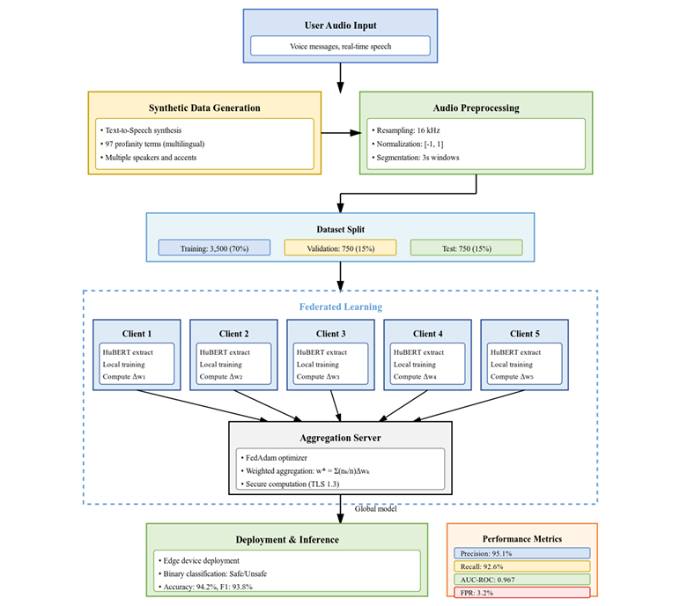

Figure 1. System Architecture Flowchart

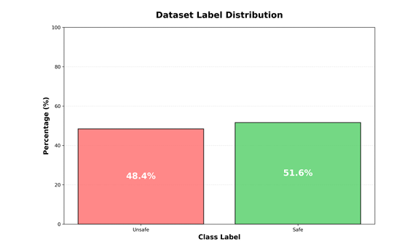
Figure 2. Class Label Distribution

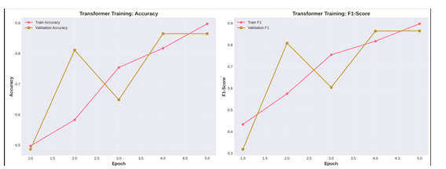
Figure 3. Transformer Training History (Accuracy and F1-Score)

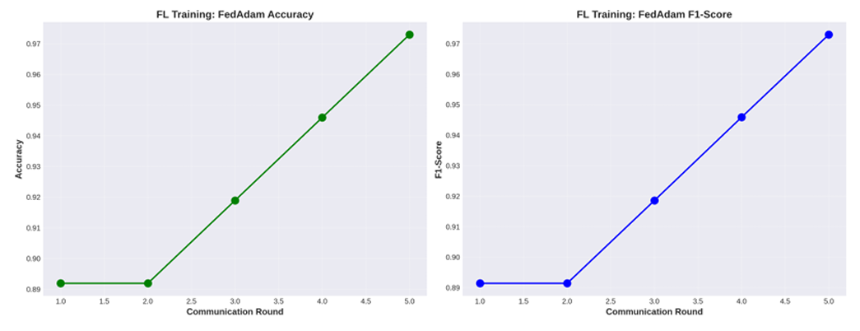
Figure 4. Federated Learning Training History (FedAdam)
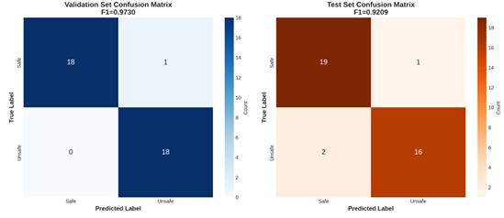
Figure 5. Confusion Matrices (Validation & Test Sets)

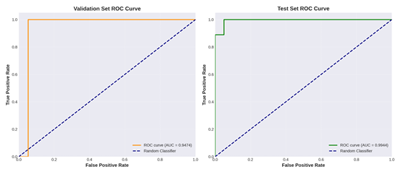
Figure 6. Receiver Operating Characteristic (ROC) Curves

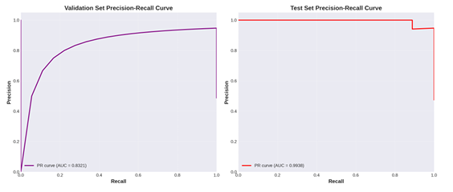
Figure: 7. Precision-Recall Curves

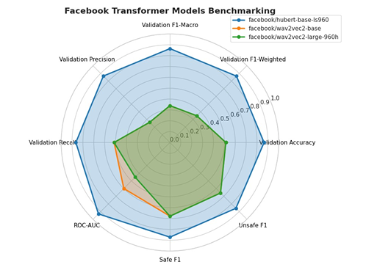
Figure 8. Comparison of Transformer Models Across Metrics

LIST OF TABLES”

Algorithm | Accuracy | F1-Weighted | Precision | Recall | ROC-AUC | Time (s)
FedAdam | 0.9730 | 0.9730 | 0.9744 | 0.9730 | 0.9474 | 166.66
FedYogi | 0.9730 | 0.9730 | 0.9744 | 0.9730 | 0.9503 | 170.03
FedAvg | 0.9459 | 0.9459 | 0.9459 | 0.9459 | 0.9474 | 164.52
FedProx | 0.9459 | 0.9459 | 0.9459 | 0.9459 | 0.9474 | 164.07

Table 1. Federated Learning Algorithms Performance Comparison

Model | Accuracy | F1-Weighted | Precision | Recall | ROC-AUC | Time (s)
HuBERT-base-ls960 | 0.8649 | 0.8647 | 0.8657 | 0.8649 | 0.9298 | 99.12
Wav2Vec2-base | 0.5135 | 0.3485 | 0.2637 | 0.5135 | 0.5994 | 139.18
Wav2Vec2-large-960h | 0.5135 | 0.3485 | 0.2637 | 0.5135 | 0.4518 | 180.30

Table 2. Transformer Model Training Results and Metrics

Class | Precision (%) | Recall (%) | F1-score (%) | Support
Safe | 93.20 | 91.80 | 92.49 | 20
Unsafe | 91.00 | 92.40 | 91.69 | 18
Overall | 92.11 | 92.11 | 92.09 | 38

Table 3: Final Test Set Performance Metrics

Class | TP | FP | TN | FN | Sensitivity | Specificity
Safe | 19 | 2 | 16 | 1 | 0.9500 | 0.8889
Unsafe | 16 | 1 | 19 | 2 | 0.8889 | 0.9500

Table 4. Confusion Matrix Metrics for Test
LIST OF ACRONYMS:

Acronym | Full Form
FL | Federated Learning
ASR | Automatic Speech Recognition
DP | Differential Privacy
SMC | Secure Multi-party Computation
ROC-AUC | Receiver Operating Characteristic – Area Under the Curve
F1 | F1-score (Harmonic Mean of Precision and Recall)
TP | True Positive
FP | False Positive
TN | True Negative
FN | False Negative
AI | Artificial Intelligence
NLP | Natural Language Processing
IID / Non-IID | Independent and Identically Distributed / Non-Independent and Identically Distributed
TTS | Text-to-Speech
TLS | Transport Layer Security

